DANO AIRLINE CUSTOMER SATISFACTION ANALYSIS

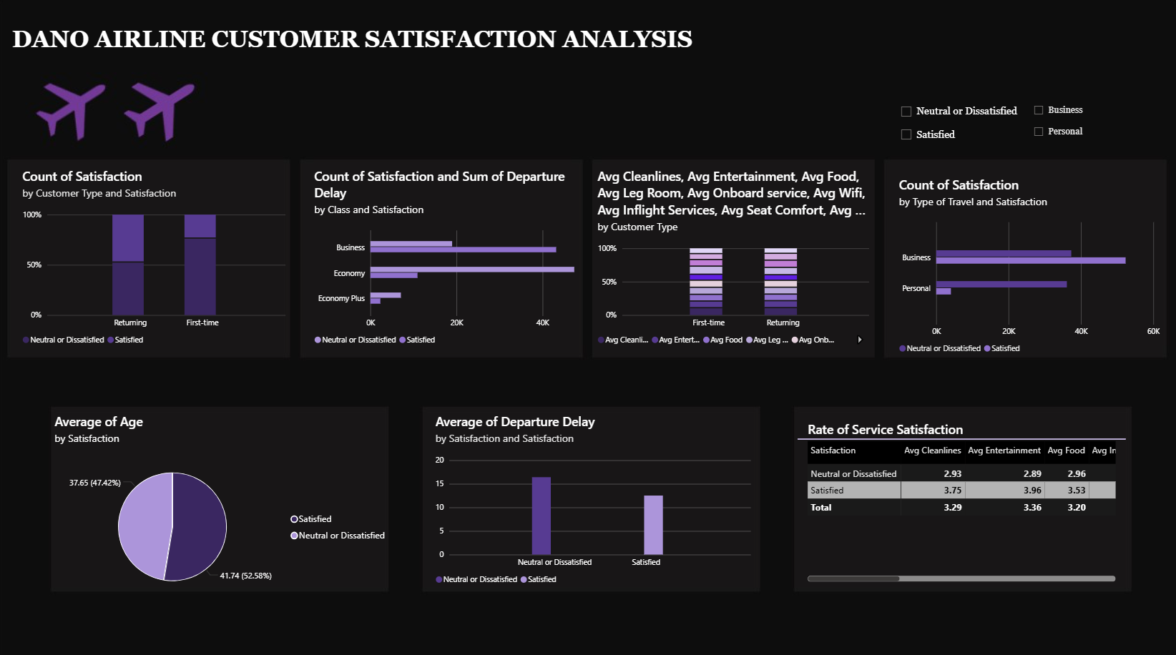

REPORT

After analyzing 129,880 passenger records, I found that Dano Airlines has a satisfaction rate of only 43.45%, confirming management's concern that satisfaction has fallen below 50%.

IMPORTANT FINDINGS

The problem is not one single issue, Customer dissatisfaction is being driven by a combination of:

1. Poor online boarding experience
2. Weak in-flight entertainment experience
3. Seat comfort concerns
4. Poor economy-class experience
5. Lower satisfaction among first-time customers
6. Flight delays

The data was cleaned and the “Arrival Delay” column contained missing values.

I replaced missing values appropriately while minimizing distortion and no significant duplicate passenger records affecting analysis were identified.

Some average service ratings across all passengers includes
SERVICE | AVERAGE RATINGS
In-flight Wi-Fi Service | 2.73
Ease of Online Booking | 2.76
Gate Location | 2.98
Departure & Arrival Convenience | 3.06

The lowest-rated service is: In-flight Wi-Fi Service is (2.73/5)
Closely followed by:

* Online Booking
* Gate Location
* Schedule Convenience
N/B These areas should become immediate improvement priorities.

Customer Satisfaction by Travel Class
Critical Insight

Economy passengers are overwhelmingly dissatisfied with them having the lowest satisfaction rating.
Business-class passengers are nearly 4 times more satisfied than Economy passengers and this is the strongest operational issue uncovered.

Customer Satisfaction by Travel Purpose
Findings

Personal travelers are highly dissatisfied with only about 1 in 10 leisure passengers reporting satisfaction.
This suggests Dano Airlines is currently serving business travelers much better than leisure travelers.

Customer Satisfaction by Customer Type
Findings

First-time customers are far less satisfied.
This is dangerous because dissatisfied first-time passengers are unlikely to become loyal customers.

Impact of Delays
Findings

Dissatisfied passengers experience longer delays.
Although delays are not the only issue, they contribute significantly to customer dissatisfaction.

What Separates Satisfied and Dissatisfied Customers?

I compared service ratings between satisfied and dissatisfied passengers, with the Strongest Drivers of Satisfaction as:
- Online Boarding
- In-flight Entertainment
- Seat Comfort
- On-board Service
- Leg Room Service
- Cleanliness and
- In-flight Wi-Fi

Interpretation

The largest difference is Online Boarding
Satisfied passengers rated Online Boarding much higher than dissatisfied passengers.
This makes Online Boarding the strongest predictor of satisfaction in the dataset.

Recommendations
1. Improve the Online Boarding Experience
This is the single largest driver of satisfaction which will cause very high impact

Actions:
* Redesign mobile check-in process
* Reduce boarding wait times
* Improve boarding communication
* Enhance app usability

2. Upgrade Economy-Class Experience
Economy satisfaction is critically low.

Actions:
* Improve seat comfort
* Increase legroom where possible
* Improve food offerings
* Enhance customer service

3. Invest in Better In-flight Entertainment and Wi-Fi
Both services show strong relationships with customer satisfaction.

Actions:
* Upgrade Wi-Fi reliability
* Improve entertainment content library
* Enhance streaming quality

4. Reduce Flight Delays

Actions:
* Improve scheduling efficiency
* Enhance turnaround operations
* Strengthen delay communication

5. Focus on First-Time Customers

Actions:
* Welcome programs
* Better onboarding communication
* First-flight support initiatives

Conclusion

Dano Airlines' satisfaction crisis is primarily driven by poor experiences among:
* Economy passengers
* Personal travelers
* First-time customers

The strongest operational factors affecting satisfaction are:
1. Online Boarding
2. In-flight Entertainment
3. Seat Comfort
4. Leg Room Service
5. Wi-Fi Quality

If management prioritizes these five areas, particularly the economy-class experience and online boarding process, customer satisfaction should improve significantly and move back above the 50% threshold.

